# CS 255 System Design Document Template

## UML Diagrams

### UML Use Case Diagram

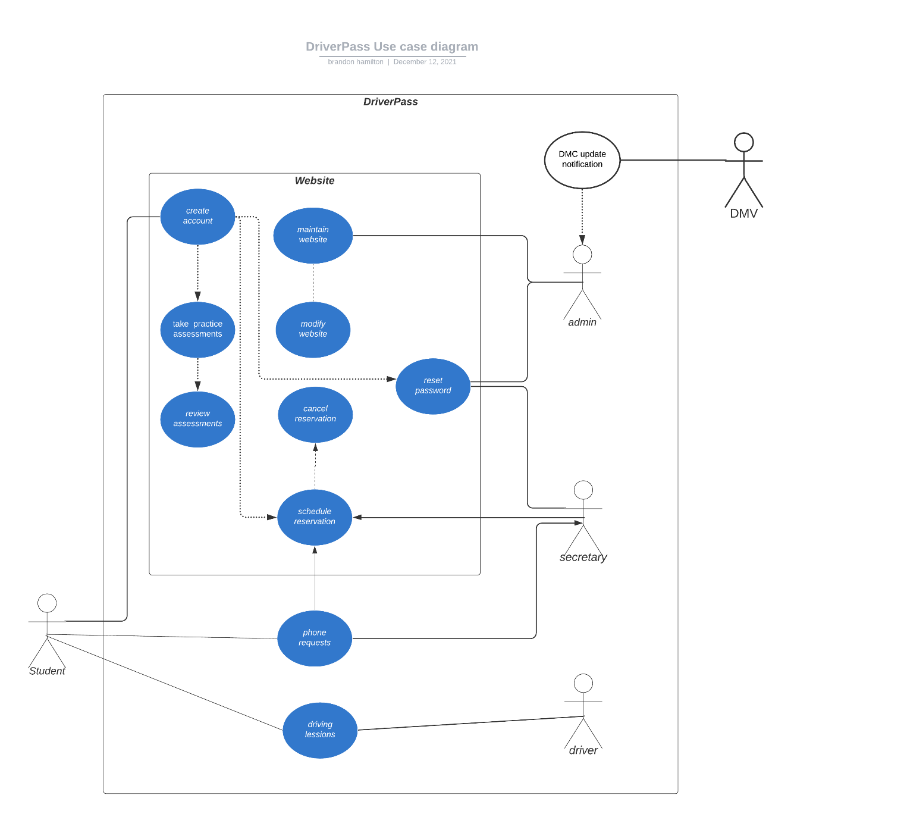

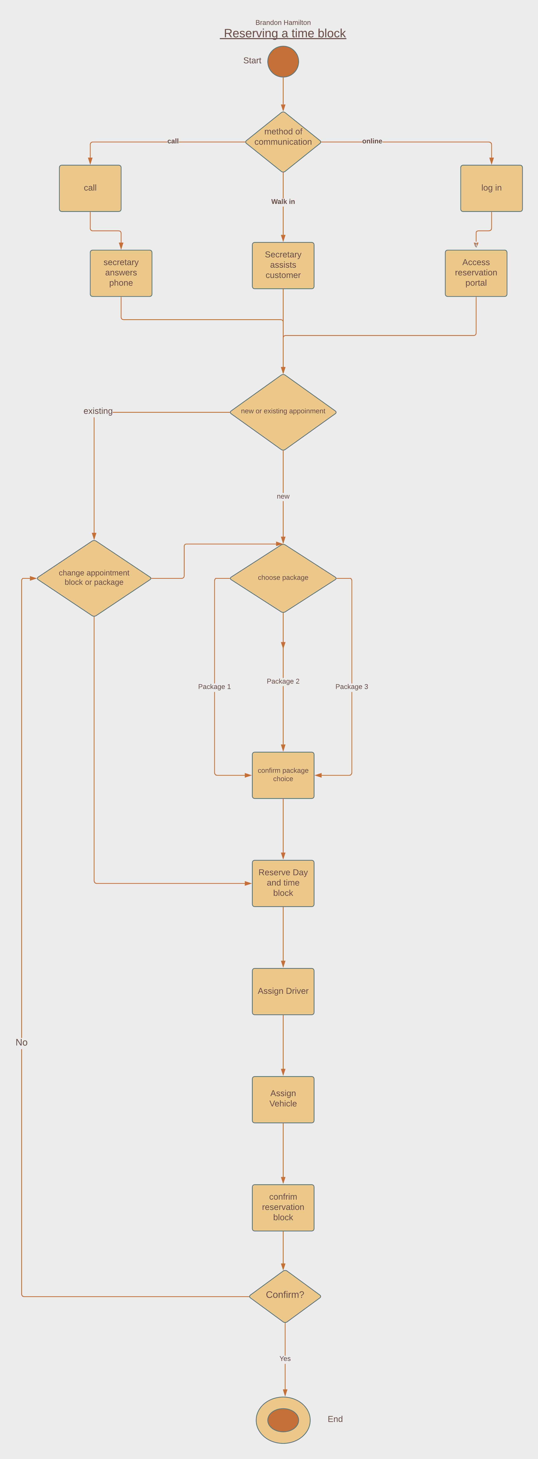

### UML Sequence Diagram

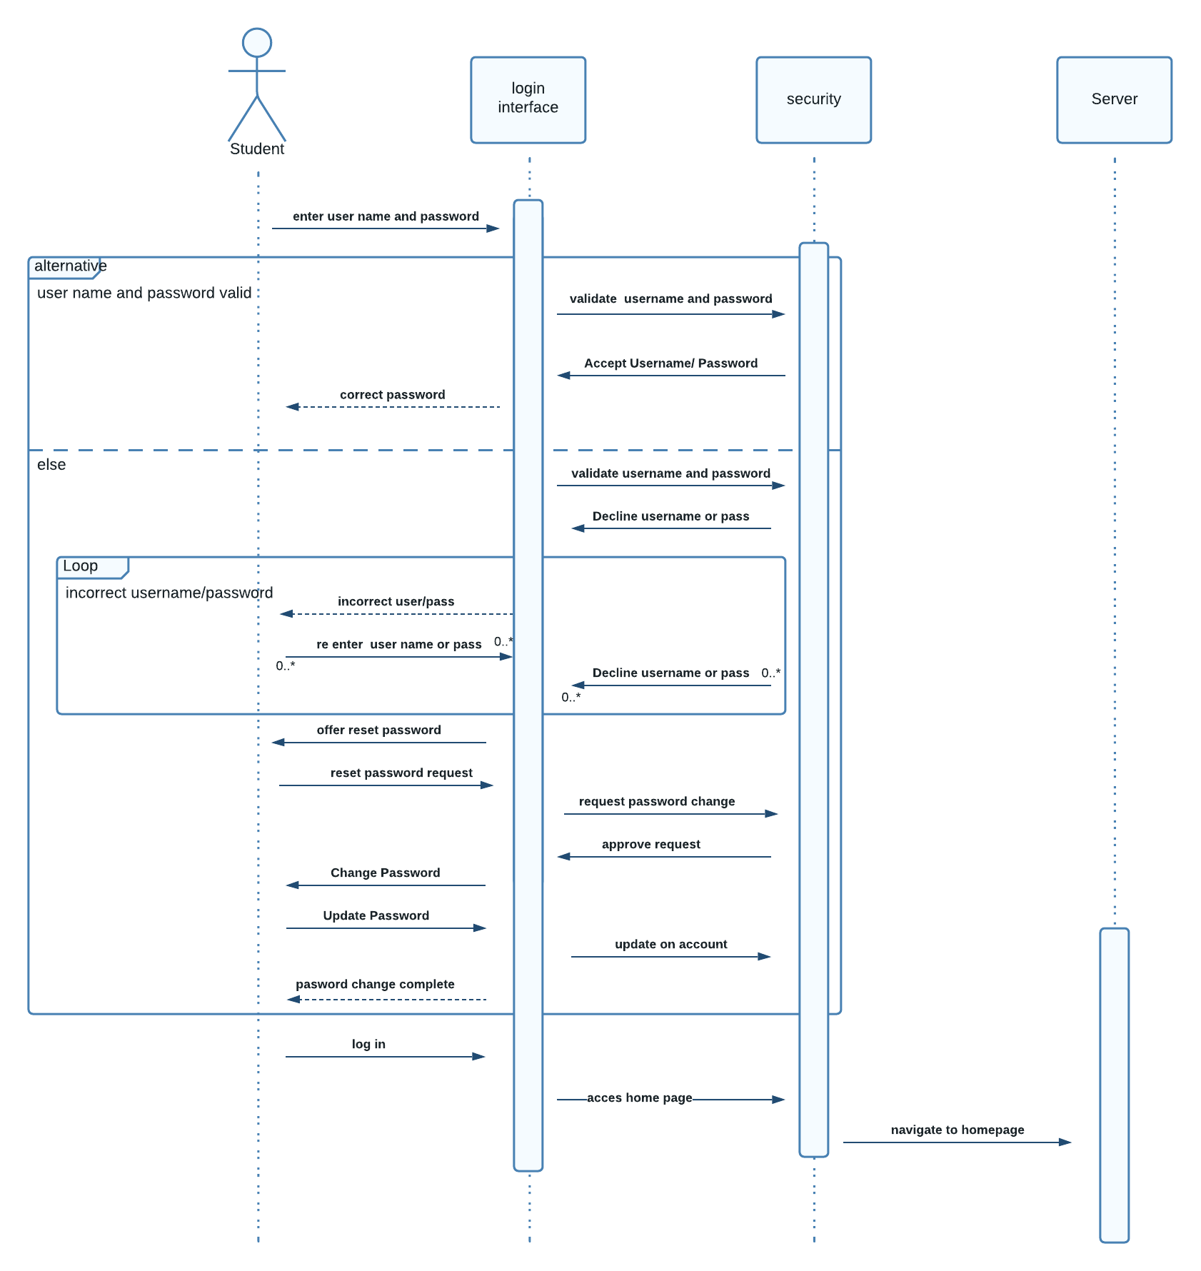

### UML Class Diagram

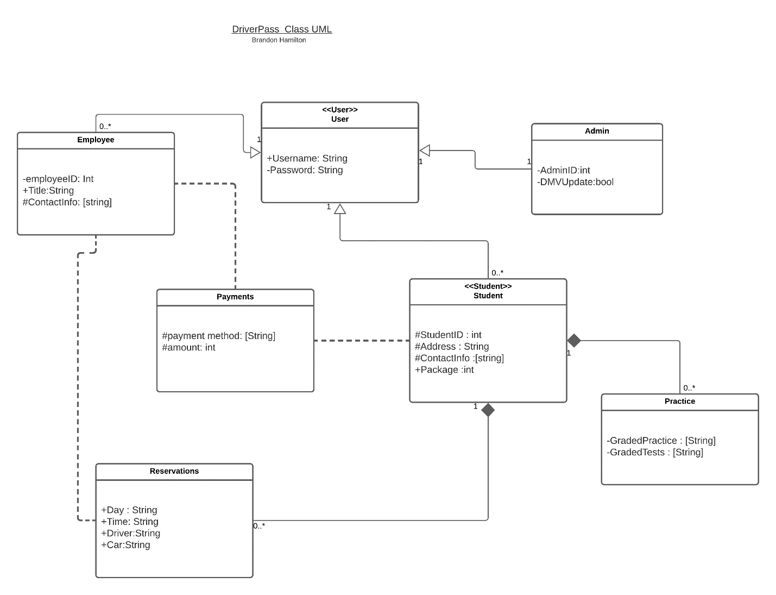

## Technical Requirements

Web service Provider- will allow access to the webpage and its contents, will handle majority pf security and database access.

Database- To hold logs, transactions, student, employee information, and DMV updates.

Restful API- Framework that allows client-server communication needed for web-based services

CPN with remote access- a layer of protection to contain internal systems remotely.

Point of Sale System- Secure payment portal to process transactions.